Sound Thesis HOME PHILOSOPHY THESIS NOTES SERVICES WHY WE EXIST

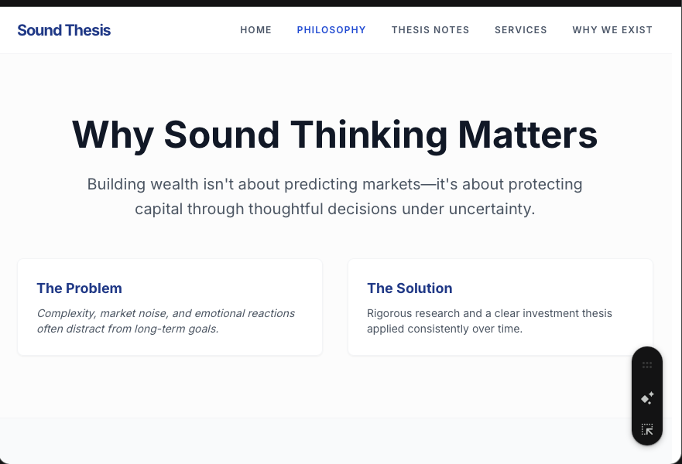
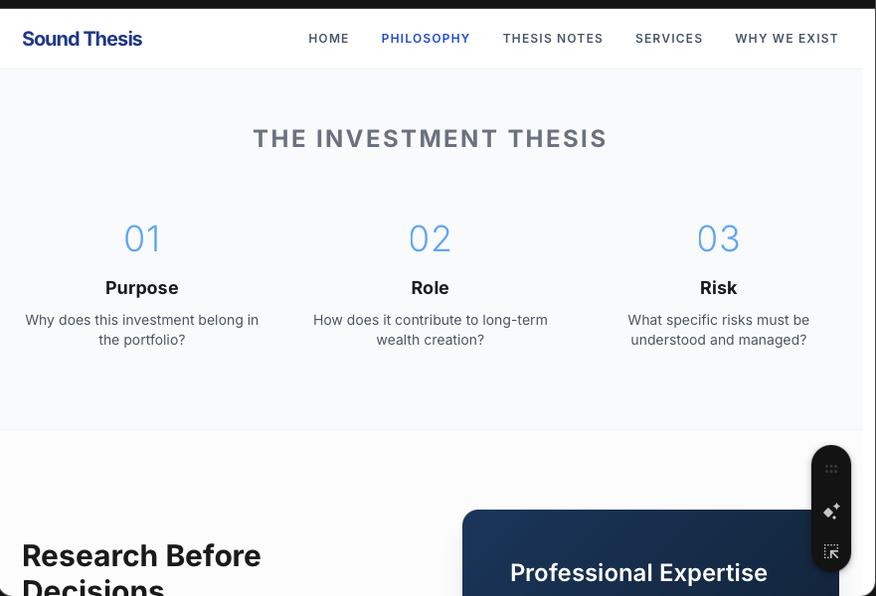
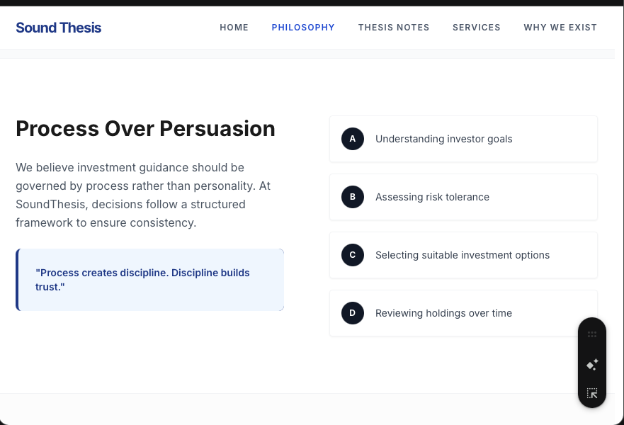
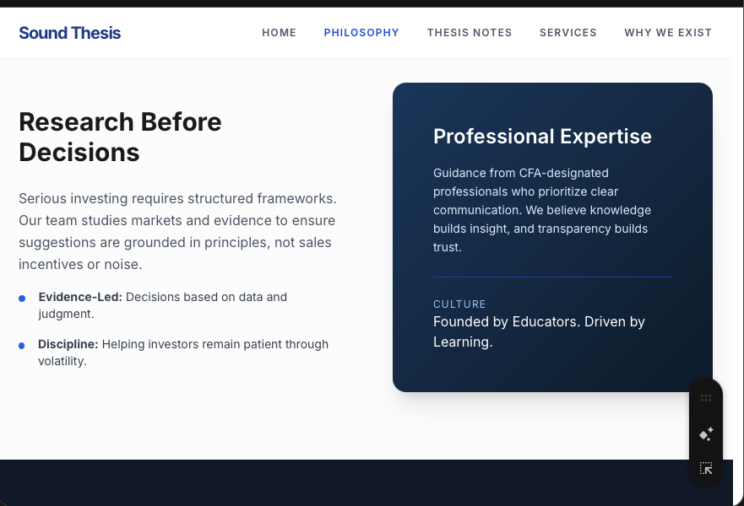
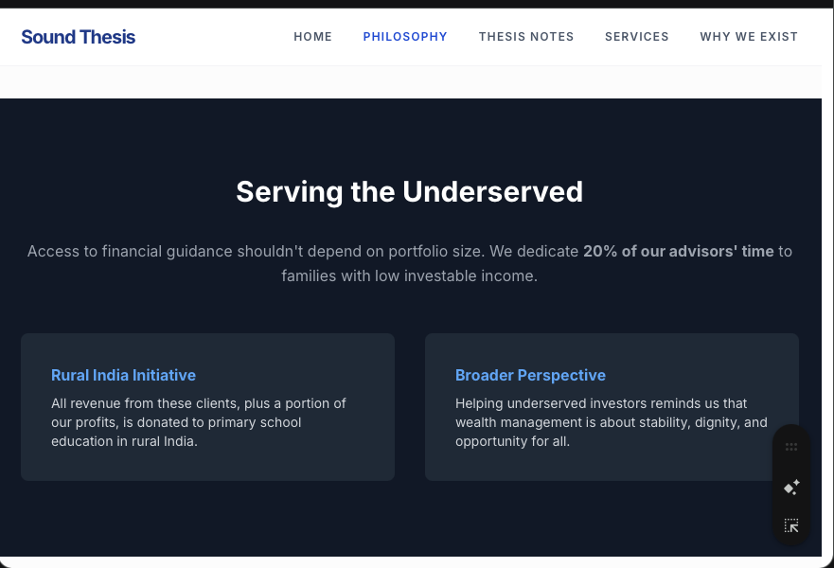
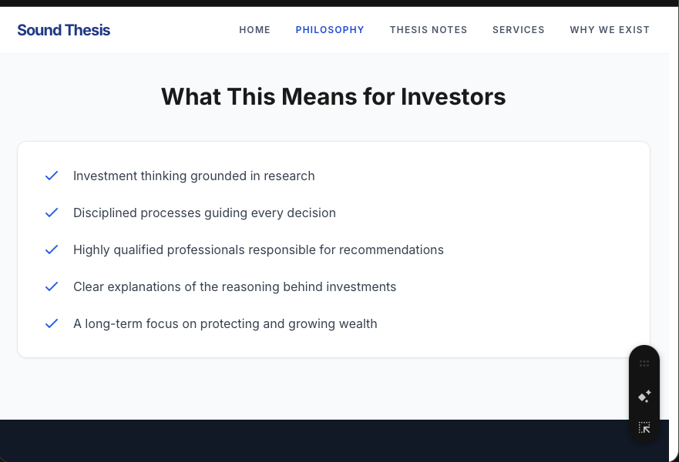
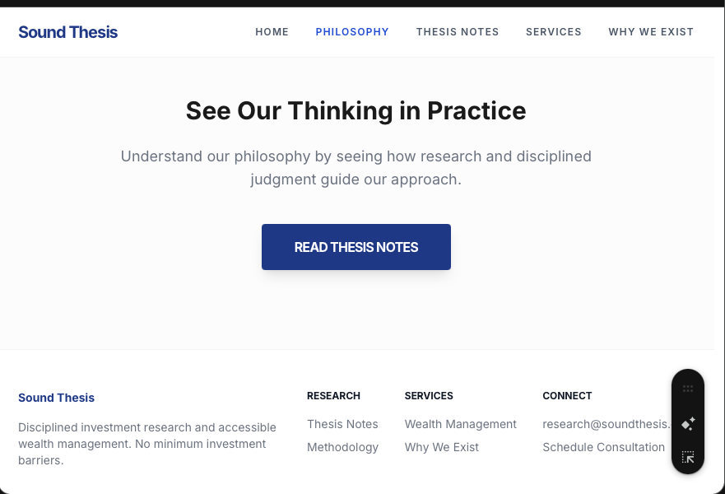

Why Sound Thinking Matters
Building wealth is not about predicting or reacting to markets.
It is about protecting and growing capital by making thoughtful decisions under uncertainty — across changing economic conditions, evolving opportunities, and unpredictable market cycles.
Markets are complex. Investment products are numerous. And short-term movements often distract investors from long-term goals.
Successful investing requires something more fundamental:
sound thinking applied consistently over time.
Sound thinking involves rigorous research, disciplined analysis, and professional judgment to evaluate opportunities, manage risks, and remain focused on long-term wealth creation.
At SoundThesis, every investment decision begins with a clear investment thesis — a reasoned explanation of why an investment belongs in a portfolio and how it contributes to long-term wealth creation. This means avoiding unnecessary risks and being selective about what we include in a portfolio.
This discipline helps investors navigate markets with clarity, confidence, and perspective.

Research Before Decisions
Serious investing requires serious research.
Our research team studies investment opportunities, evaluates risks, and develops structured frameworks that guide investment thinking across the firm while also adapting recommendations to each investor’s goals, risk comfort, and time horizon.
This research helps ensure that all investment suggestions are grounded in evidence, careful analysis, and long-term investment principles. The goal is simple: thoughtful decisions based on research and judgment — not sales incentives or market noise.

The Investment Thesis
Every investment should have a clear purpose.
A sound investment thesis answers three simple questions:
- Why does this investment belong in the portfolio?
- What role does it play in long-term wealth creation?
- What risks should investors understand?
Clarity of reasoning leads to better decisions and greater confidence.

Discipline Through Market Cycles
Periods of volatility often lead investors to react emotionally — buying when markets rise and selling when they fall.
Sound investing requires discipline: staying aligned with long-term goals while markets fluctuate.
Our role is to help investors remain thoughtful, patient, and focused on building wealth over time.

Professionals You Can Trust
When it comes to your life savings, you want guidance from professionals who truly understand what they are doing.
Our team consists of highly qualified finance professionals trained in investment analysis and wealth management with advanced credentials such as the CFA designation.
Equally important, they are trained to communicate clearly — helping investors understand the reasoning behind investment decisions.
Knowledge builds insight. Clear communication builds trust.

Serving the Underserved
Access to responsible financial guidance should not depend entirely on portfolio size.
Many individuals with modest savings struggle the most to build financial security. For this reason, 20% of our advisors’ time is dedicated to serving traditionally underserved families with low investable income.
All revenue generated from serving these clients is donated to a charitable trust supporting primary school education in rural India. In addition, SoundThesis also donates a portion of its profits to this initiative.
This reflects our roots as educators — and our belief that financial knowledge and opportunity should reach more people.
Working with underserved investors also shapes our advisors’ perspective. It reminds us that wealth management is not only about portfolios, but about helping people build stability, dignity, and opportunity.

A Culture of Learning
SoundThesis was founded by educators who have trained thousands of professionals for careers in investment research, portfolio management, and wealth management.
Learning remains central to our culture.
Our advisors continuously refine their thinking through research, discussion, and experience — ensuring our philosophy evolves while remaining grounded in disciplined principles.

Process Over Persuasion
We believe investment guidance should be governed by process rather than personality.
Many investors depend on individual advisors whose decisions may rely on intuition, experience, or product familiarity.
At SoundThesis, decisions follow a structured process that includes:
• understanding investor goals
• assessing risk tolerance
• selecting suitable investment options
• reviewing holdings over time
This ensures investment decisions remain consistent, thoughtful, and aligned with each investor’s long-term objectives.
Process creates discipline.
Discipline builds trust.

What This Means for Investors
Our philosophy translates into a simple commitment.
When you work with SoundThesis, you should expect:
- investment thinking grounded in research
- disciplined processes guiding decisions
- highly qualified professionals responsible for recommendations
- clear explanations of the reasoning behind investments
- a long-term focus on protecting and growing wealth

See Our Thinking in Practice
The best way to understand our philosophy is to see how we think.
Explore our Thesis Notes to see how research, disciplined thinking, and investment judgment guide our approach.
Read Thesis Notes

The Case for Openness
For decades, the most sophisticated financial research has been locked away - developed in closed environments, validated by internal committees, At Sound Thesis, we believe this model is fundamentally flawed. Not because exclusivity is inherently wrong, but because closed systems produce weaker outcomes. Research that cannot be scrutinized cannot be trusted. Models that aren't stress-tested by diverse perspectives carry hidden risks.

We believe that transparency leads to better outcomes. We apply this principle to financial research. When our methodologies are open to scrutiny, they become stronger. When our models are transparent, they become more reliable.

This is not about giving away competitive advantage. It's about building a foundation of trust that closed institutions cannot match. Our advantage comes not from secrecy, but from the rigor that openness demands.

Sound Thesis HOME PHILOSOPHY THESIS NOTES SERVICES WHY WE EXIST
and shared only with those who could afford the price of admission.

The Transparent Advantage
How our approach differs from traditional research firms.
Our Process

How transparent research translates to portfolio outcomes.

Our Founder
Researchers committed to open, rigorous analysis.

Sound Thesis
HOME
PHILOSOPHY
THE IS NOTES
SERVICES
WHY WE EXIST
Dr. Sarah Mitchell
CHIEF RESEARCH OFFICER
Michael Chen, CFA
DIRECTOR, ASSET ALLOCATION
Dr. Priya Sharma
HEAD OF QUANTITATIVE RESEARCH
Ph.D. Economics, Stanford.
Former macro research lead at Goldman Sachs.
15 years managing multi-
asset portfolios. Former PM at Bridgewater.
Ph.D. Financial Engineering,
MIT. Expert in factor models.

S

See Our Philosophy in Action
Explore our research to understand how these principles translate into actionable insights.

Sound Thesis HOME PHILOSOPHY THESIS NOTES SERVICES WHY WE EXIST
R E A D T H E S I S N OT E S

Sound Thesis
Democratized financial research and accessible wealth management. No minimum investment barriers.
RESEARCH

Thesis Notes Methodology
SERVICES

Wealth Management Why We Exist
CONNECT

research@soundthesis.com Schedule Consultation

© 2024 Sound Thesis. All rights reserved. Democratized Research. Transparent Wealth Management.

